TEE-SHIRT ORDER FORM

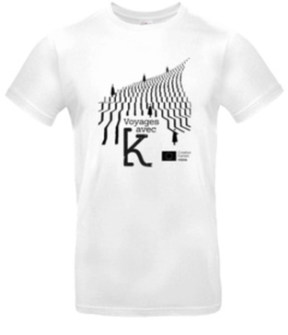
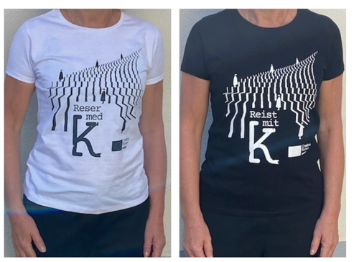
Tee-shirt design TRAVELS WITH K.
100% cotton I weight : 185 grams/m²

Size : S/M/L/XL/2XL
Version : man or woman
Colors : white or black
Writting : in French, Swedish or German
Regular price : 15 € (Tax and shipping included).

- COSTUMER DETAILS

Name : ………………………………………………………………………………………………………………………………….

Address of delivery : ……………………………………………………………………………………………………….……

Cod post : …………………………………….………………………………………………………………………………………

City : ………………………………………………….…………………………………………………………………………………

State/ Country …………………………………………………………………….………………………………………………

Phone number : ………………………………………………………………………………………………………………….

Email : …………………………………………………………………………………………………………………………………

Order date : ……………………………………………………………………………………………………………………….

ORDER DETAILS

Quantity | Size | Version | Colors | Language | Price | Sub-total (€)

Total TTC (€)
Payment by bank tranfer

Please send this order form back to us by email.
We will answer you as soon as possible and send you invoice with our bank details.
The order will be delivered to the address of delivery which you will have indicated on this order
once payment received.

LES LUCIOLES – T. +33 (0)6 49 29 47 25 – theatredeslucioles@wanadoo.fr

